GRVLUP
DIRT ROADS · GOOD COMPANY
PRESS KIT — 2026

About GrvlUp
One-line boilerplate
GrvlUp is the community platform where gravel riders find curated dirt-road routes by region, download them free for offline navigation, and ride them in good company.
Full boilerplate
GrvlUp curates the best gravel riding on earth, one region at a time. Every route in the GrvlUp library is scouted, documented, and organized into regional collections with surface notes, tire recommendations, resupply points, and honest difficulty ratings. Members download routes free for offline, turn-by-turn navigation and connect with riders exploring the same dirt. GrvlUp exists because the best gravel rides are passed rider to rider — and every rider deserves to be in on it.

The Story
We've all been on rides miles from anything, second-guessing whether we should have chosen this route. The great rides are out there — but they're buried in forums, local knowledge, and scattered GPX files, passed rider to rider only if you happen to know the right one.
GrvlUp is the decision to build the place where regional gravel knowledge lives. The vision: a rider-built atlas of dirt roads, region by region — scouted, documented, and shared, so no rider has to guess.

The Platform
- Curated regional route collections — scouted routes organized by region, distance, surface, and difficulty, not an unfiltered dump of user uploads.
- Free downloads and navigation for members — offline route downloads and turn-by-turn voice navigation on every GrvlUp route at no cost, via the Ride with GPS club platform.
- Route intel that matters — tire recommendations, surface breakdowns, water and resupply stops, and photos from riders who have actually ridden it.
- Good company — group rides, regional challenges, and a community feed connecting riders who share the same dirt.

Fast Facts
Founded | 2026
Founder | Jonah G.
Headquarters | Greensburg, Indiana
Platform | grvlup.com · GrvlUp Club on Ride with GPS
Routes curated | [XX] routes across [X] regions at launch
Members | [XXX] founding members
Membership | Free to join — includes offline downloads and turn-by-turn navigation on all club routes

Founder
Jonah G. is a tech worker by day and a gravel and road cyclist every evening and weekend he can carve out. GrvlUp started small, and a little sideways: a project to try out new tools and new ways of building, and a good excuse to meet other people who ride. The more Jonah dug into local routes, the more the real problem stood out — the best gravel was always out there, but the knowledge of where to find it was scattered across forums, Strava comments, and other riders' phones, never in one place. GrvlUp is Jonah's attempt to put it in one place: routes scouted and organized region by region, built in the same evening and weekend hours spent riding them, with the community that's grown around it as the actual point — the routes are just the reason to ride together.
[Attach a high-res founder headshot (grvlup-founder.jpg) alongside this kit.]

Brand Assets — Logos
SVG masters are the source of truth for all production use. PNG exports below are provided at 512 / 1024 / 2048px (transparent background) for platforms that reject SVG — app store listings, social profile uploads, embroidery and print vendors.
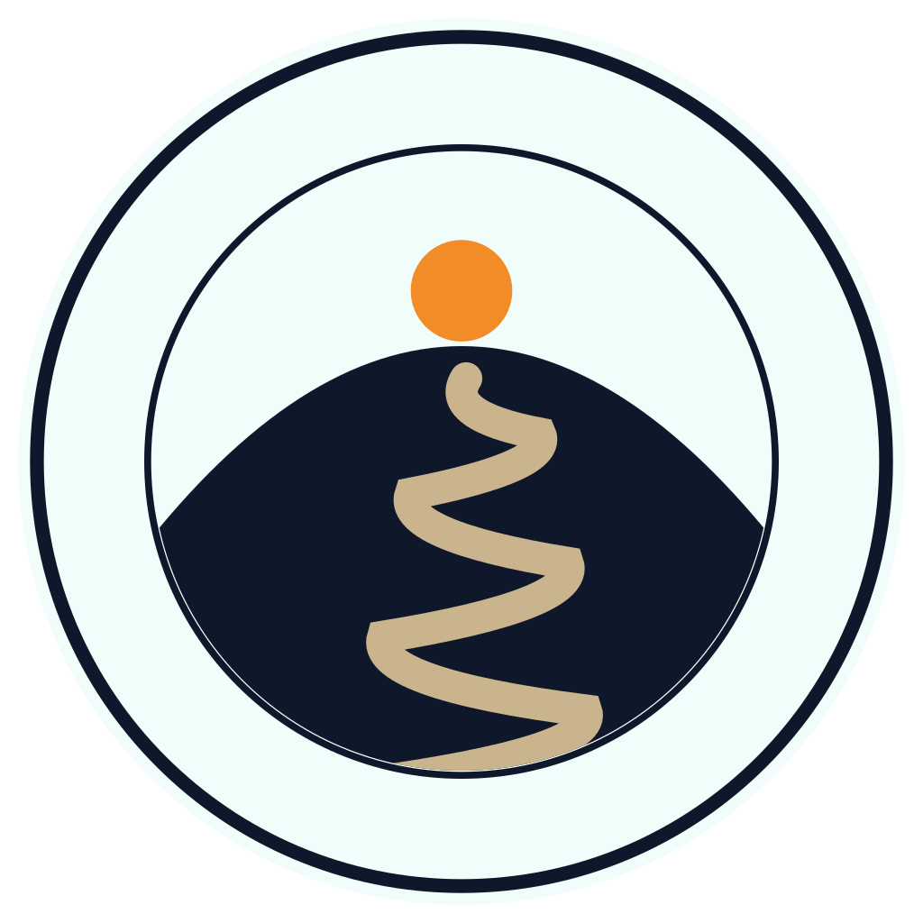
grvlup-v2-badge — primary badge. Switchback road to summit sun inside the roundel. This badge's palette is the master color reference.
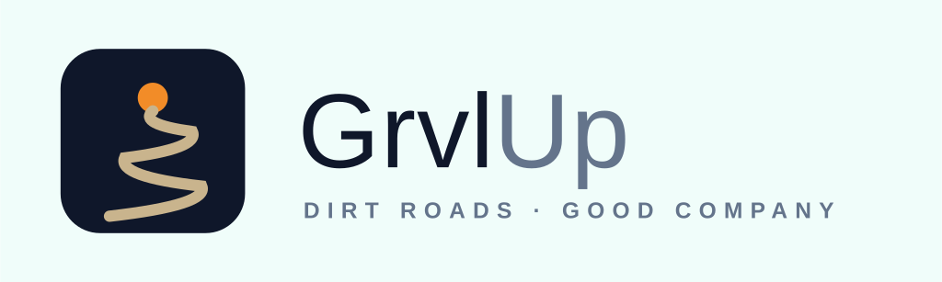
grvlup-v2-lockup-horizontal — icon tile + wordmark + tagline. Website header, banners, email signatures.
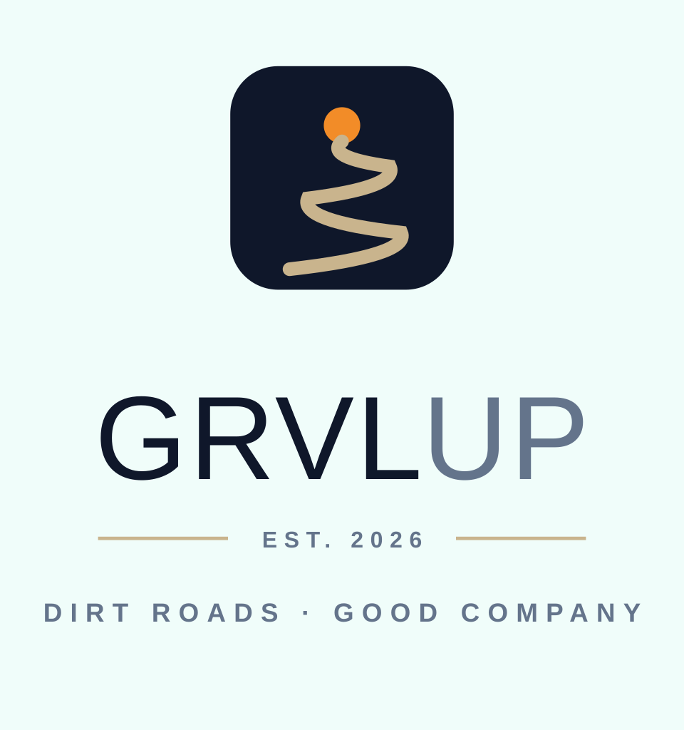
grvlup-v2-lockup-stacked — centered icon over wordmark. Social profiles, splash screens, merch.
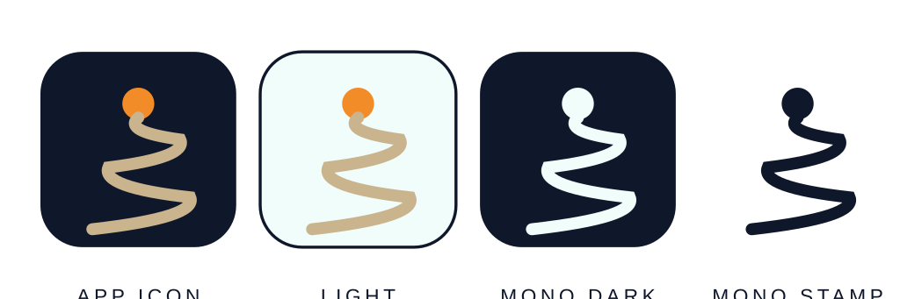
grvlup-v2-icon-sheet — app icon in primary, light, and two mono treatments. Favicon, app stores, avatars.
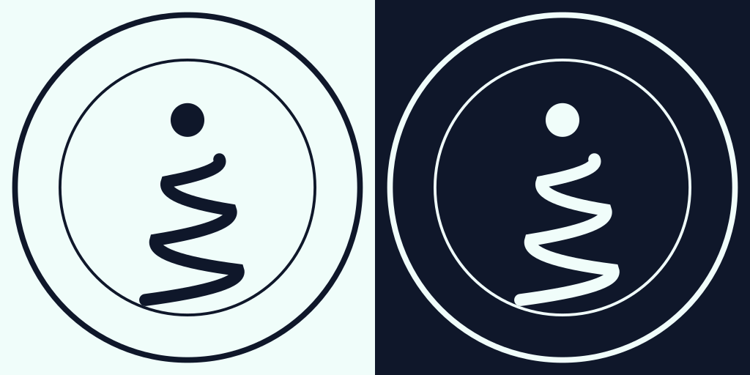
grvlup-v2-mono-badges — strict one-color badges for embroidery, stamps, laser etch.

Color Palette
Logo and print palette (as seen in the badge): Navy · Mint · Slate · Sun Orange · Dirt. Teal and Teal Light are digital accents reserved for the website and app, and are never used in the standalone logo files. GrvlUp shares the Navy/Mint foundation with the BridgeOps.IO brand family.
 | Color | Category | Usage
 | Navy  #0F172A | Logo & print | Primary dark — badge background, wordmark.
 | Mint  #F0FDFA | Logo & print | Primary light — background, badge ring.
 | Slate  #64748B | Logo & print | The “Up” in wordmark lockups.
 | Sun Orange  #F28C28 | Logo & print — protected | Always the summit sun. Never recolored.
 | Dirt  #C9B48D | Logo & print — protected | Always the switchback road. Single continuous line.
 | Teal  #0D9488 | Digital accent | Website / app only — never in standalone logos.
 | Teal Light  #14B8A6 | Digital accent | Website / app only — never in standalone logos.

Logo Usage Guide
Protected elements
- The summit sun is always Sun Orange (#F28C28) — never recolored, including in tinted or dark-mode contexts.
- The switchback road is always Dirt (#C9B48D) and always a single continuous line — no dots, texture, or breaks — except in strict one-color (mono) treatments.
- In the lockups, the “Up” in the wordmark is always Slate (#64748B); “Grvl” is Navy.
Clear space & minimum size
- Minimum clear space around the badge on all sides equals the diameter of the summit sun circle.
- Do not reproduce the full-color badge below roughly 24px / 0.25in — the switchback detail becomes illegible at small sizes. Use the mono stamp mark from the icon sheet for favicons, avatars, or embroidery at small scale instead.
Backgrounds
- Do not place the full-color badge or lockup on low-contrast or busy/photographic backgrounds.
- On brand-color, dark, or photographic backgrounds, use the appropriate mono treatment (mono-dark or mono-stamp) from the icon sheet instead of the full-color mark.
Don'ts
- Do not stretch, skew, or distort any logo file.
- Do not recolor the badge or lockups outside the locked palette above.
- Do not add drop shadows, gradients, outlines, or other effects.
- Do not rotate the mark or recombine elements from different lockups into a new composition.
File formats & production
- SVG files are the master source — request them directly for any print, merch, or vendor production use.
- PNG exports (512 / 1024 / 2048px) are provided in this kit for platforms that require raster files.
- Production wordmarks should be converted to outlines before sending to a print or embroidery vendor.

Typography
- Display: Anton (or a licensed equivalent, e.g. Druk or Tungsten) — headlines, wordmark.
- Body: Archivo — running text, UI.
- Data / labels: IBM Plex Mono — stats, captions, kickers.

Find Us
- Web: grvlup.com
- Ride with GPS: GrvlUp Club — ridewithgps.com/organizations/21465-grvlup
- Strava: strava.com/clubs/grvlup
- Instagram: @grvlup
- YouTube: @GrvlUp — youtube.com/@GrvlUp

Media Contact
Jonah G. · Founder, GrvlUp
info@grvlup.com
High-resolution logos, lifestyle photography, and founder interviews available on request.

